13 Erdenheim Road
Erdenheim, PA 19038

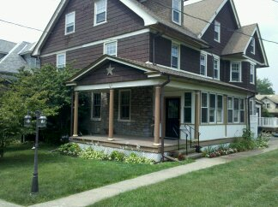

Asking: $389,000
Contact: Patrick J. Lawn
Cell: 267-312-0780
E-Mail: patrickjlawn@aol.com

Large three story, six bedroom turn of the century Victorian twin in desirable Erdenheim neighborhood. High ceilings, deep window sills and beautiful original trim woodwork throughout makes this home a must see. The first floor boasts a tiled and heated sunroom as well as front and back staircases. Built in bookshelves with bottom cabinets highlight an entire living room wall. You will love the breakfast bar, counter tops, porcelain tile floor and the numerous cabinets in the large newly renovated eat in kitchen. Upper floors feature six bedrooms with good sized closets, a large newly tiled bathroom, a powder room and double paned windows throughout. The extremely large basement with glass block ventilated windows features a laundry room with outside access, workroom with workbench, and a large playroom with cable hookup and twenty plus feet of storage closet space. Fresh paint throughout house. A rear yard new 10x12 storage shed matches the house. Ample space with plenty of room for growth in this beautiful home that is within walking distance to park, restaurants, shopping, train and quaint Chestnut Hill.

Basic Information:

Bedrooms: 6 Bathrooms: 1 Full / 2 half Built: 1903 County: Montgomery
2011 Taxes: $5,054 Heat: Oil / Hot Air Oven/Dryer: Gas Schools: Springfield
Electric: 200 amp / circuit breaker Roof: <5 years
Sq. Ft.: 3,000 + inc. sun & play rm.

Room Dimensions:

Kitchen: 17 ½ x 16 Dining Room: 16 ½ x 15
Foyer: 15 x 13 Living Room: 16 x 13 ½
Sun Room: 20 x 8 Bedroom #1: 17 x 12 ½
Bedroom #2: 14 ½ x 10 ½ Bedroom #3: 15 x 12
Bedroom #4: 17 x 14 ½ Bedroom #5: 10 ½ x 10 ½
Bedroom #6: 21 x 12 Laundry Room: 16 x 15
Work Room: 20 ½ x 15 Play Room: 28 ½ x 16
Available to show anytime!

